Chapter 10, Solution 60.

Find the Thevenin equivalent of the circuit in Fig. 10.103 as seen from:

- terminals a-b
- terminals c-d

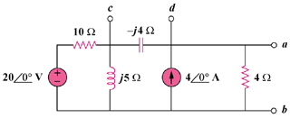

Figure 10.103
For Prob. 10.60.

Solution

- To find , consider the circuit in Fig. (a).

Z_{eq}

(a)

4

-j4

10

j5

a

b

= 1.333

To find , consider the circuit in Fig. (b).

-j4

10

200 V

40 A
+

V₁

V₂

4

j5

+

V_{Thev}

(b)

At node 1,
(1)

At node 2,
(2)

Substituting (2) into (1) leads to

Therefore,
9.61533.69 V

- To find , consider the circuit in Fig. (c).

-j4

10

4

j5

(c)

Z_{eq}

c

d

(2.667 – j4)

To find ,we will make use of the result in part (a).

9.61456.31 V

